NOTICE OF NOMINATIONS

Municipality of Brenda-Waskada

NOTICE IS HEREBY GIVEN that on October 7, 8, 9,12 and 13 between the hours of 8:30 - 12:00 and 1:00 - 4:30 at 33 Railway Avenue, Waskada I will receive nominations for the office of Head of Council of the aforesaid Local Authority.

The nomination deadline is October 13 at 4:30 pm. Nominations cannot be accepted after this day.

All nominations shall be made in writing and shall be signed by at least twenty-five voters, or NOT less than 1% of the voters (whichever is the lesser) of the authority or ward (as the case may be), but in all cases by at least two voters. Each nomination shall also be accompanied by the candidate’s declaration of qualification.

Nominations may be filed in person at the above location, on the date and hours specified, by an agent, or by fax. To obtain a nomination paper, and / or candidate’s declaration of qualification, contact the SEO at the telephone number listed below.

Nomination papers not accompanied by the required documents and not properly filed shall be rejected.

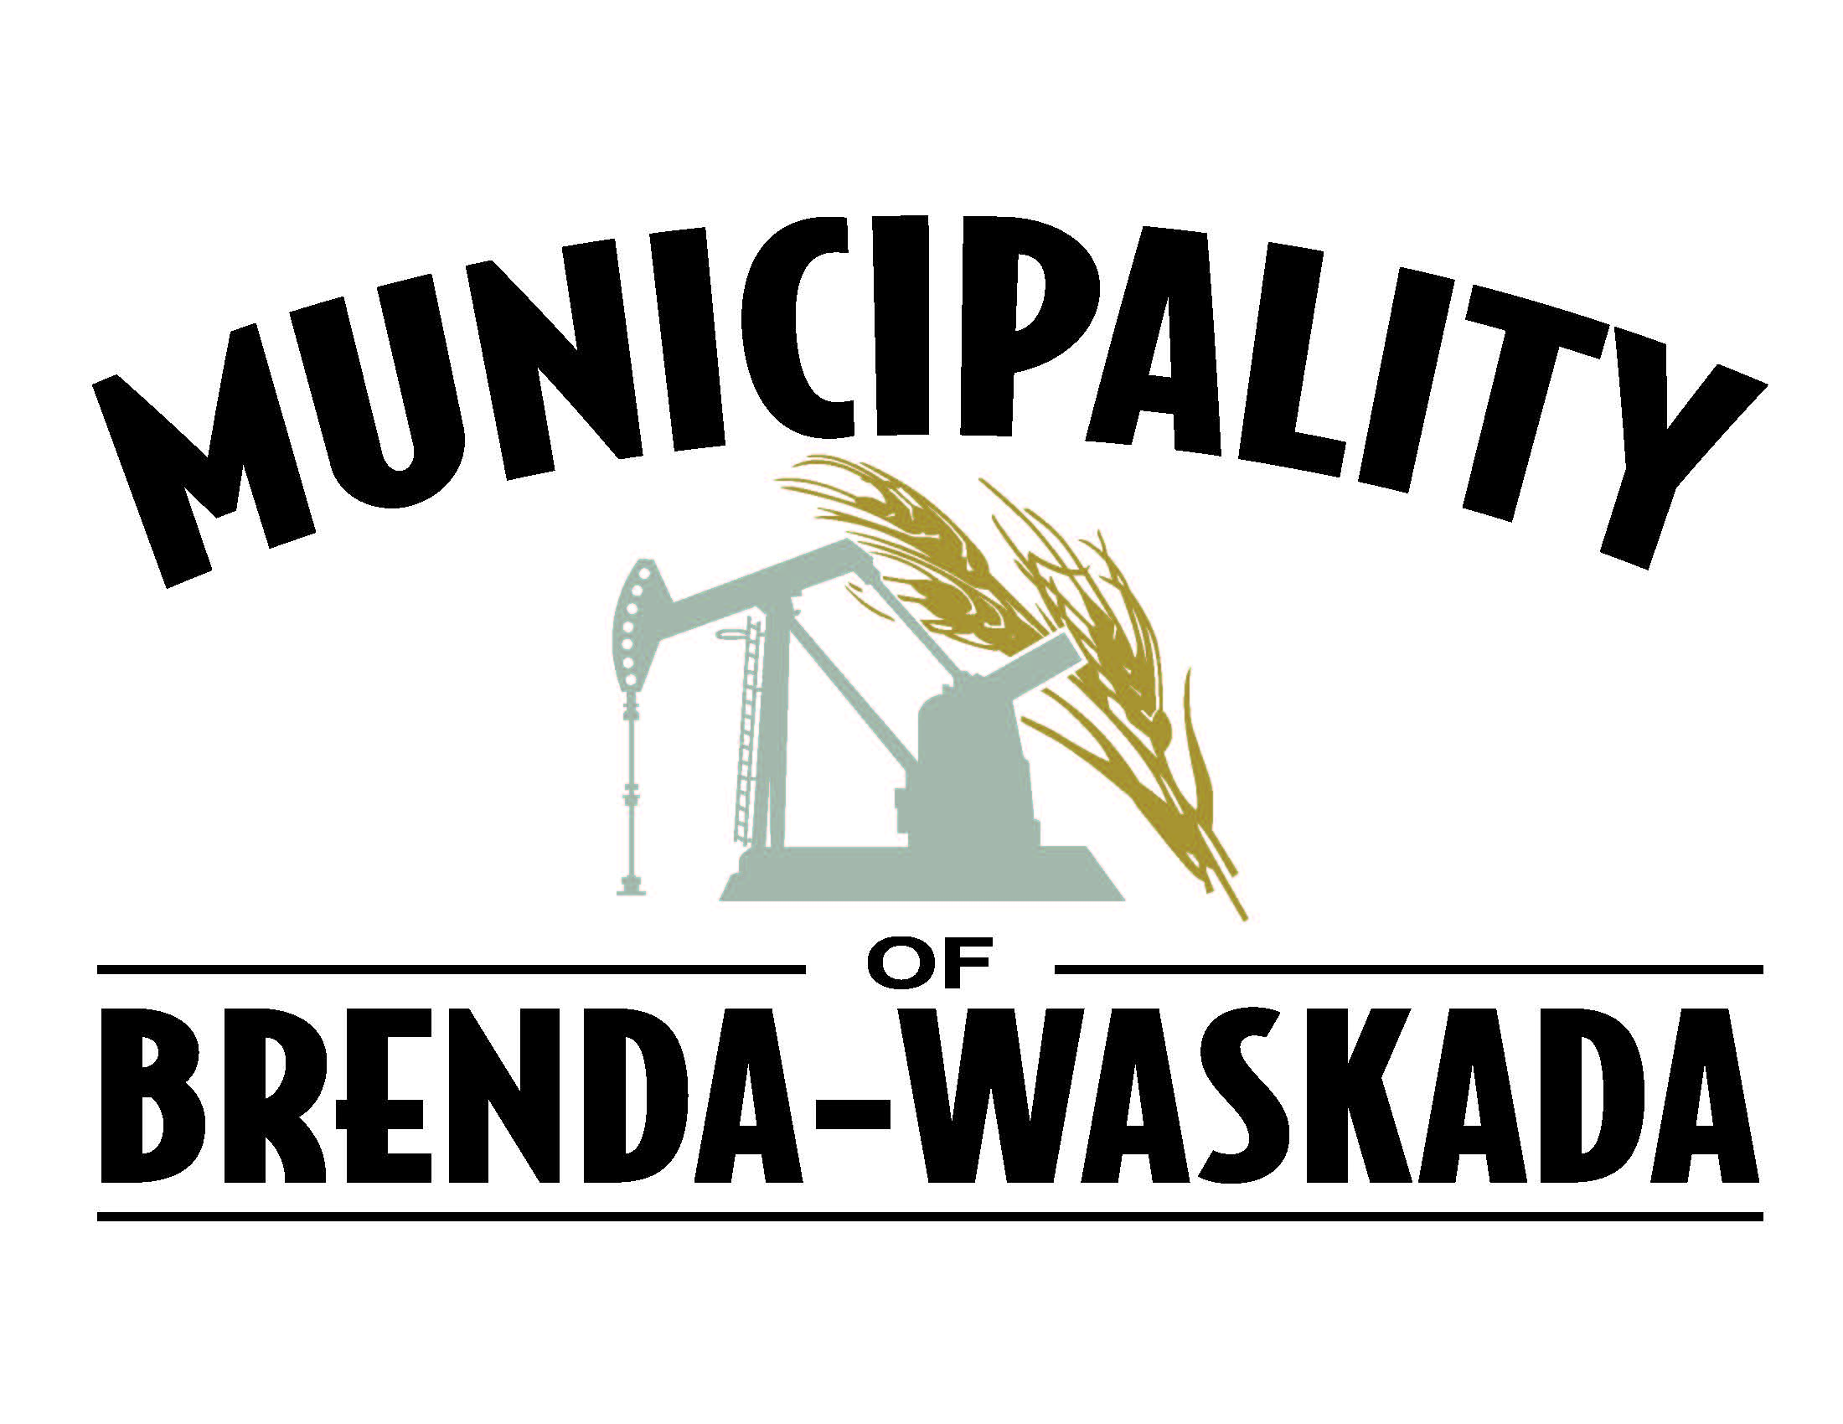

Diane Woodworth
SEO

204 673-2401 Phone
204 673-2663 Fax

Dated at Waskada on September 17, 2020.

