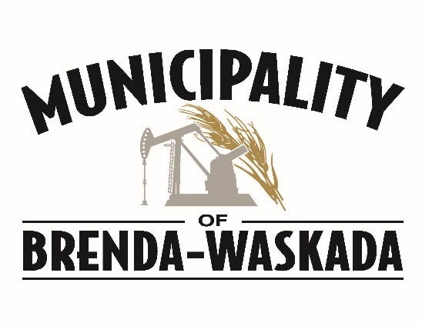

SEASONAL MOWER TENDERS WANTED

Seeking tenders for the Municipality of Brenda-Waskada to mow Medora Park and adjoining lot.
Deadline for tenders is Friday at 4:30 PM, May 13th, 2022. Tenders can be submitted to the Municipal Office.
Email: office@brendawaskada.ca
Phone: 204-673-2401, Fax : 204-673-2663

