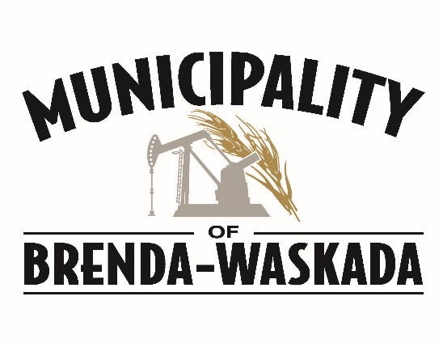

SEASONAL MOWER TENDERS WANTED

The Municipality of Brenda-Waskada is seeking tenders to mow lots in Napinka that Russ Crepeele used to cut. For a complete list please contact the Municipal office.
Deadline for tenders is Wednesday at 4:30 PM, June 1st, 2022. Tenders can be submitted to the Municipal Office.
Email: office@brendawaskada.ca
Phone: 204-673-2401, Fax : 204-673-2663

