Plant Exchange
June 4, 2022
10:30 AM
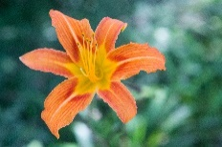 At 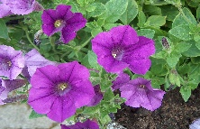
This Photo by Unknown Author is licensed under CC BY-SA
Village Inn Park
In Waskada
Feel free to bring starter plants, perennials, house plants, etc

