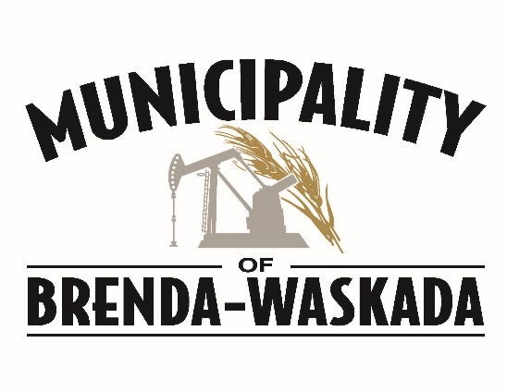

Municipality of Brenda-Waskada is accepting applications for a SEASONAL MOWER OPERATOR.

This position will primarily be the operation of a tractor and roadside mower. However, other duties involving maintenance and service may be assigned.
Anticipated start date will approximately June 15th.

Experience operating large equipment is an asset. Duration of employment will be dependent on growing conditions. Salary negotiable based on experience and qualifications. This is an hourly paid position, approximately 50 hours per week. A valid driver’s licence is a requirement.

Applications will be accepted until a suitable candidate is chosen. We appreciate your interest in this position, however, only those applicants considered for an interview will be contacted.
Municipality of Brenda-Waskada
Box 40, Waskada, MB R0M 2E0
Phone: 204 673-2401 Fax: 204 673-2663
office@brendawaskada.ca

