#whatshappeningbw
KIDS EVENT
Bouncy Castle for kids 2-5
Obstacle Course for kids 5-12
Monday July 25, 2022
At Waskada Park
1:00 to 4:00 pm
Cost is $5.00 per child, wrist band provided Children under 10 MUST have supervision
Please bring snacks and drinks and have a picnic! 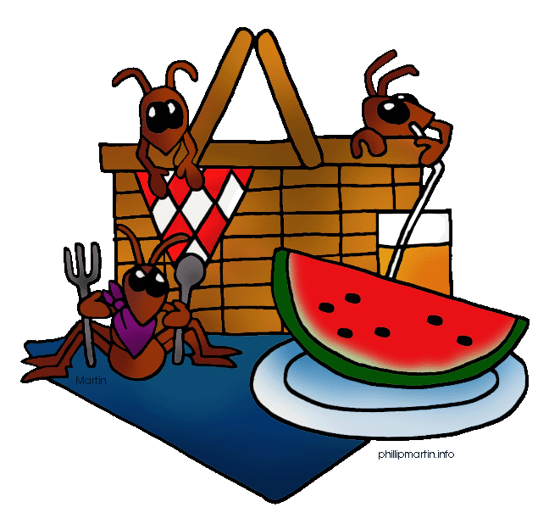
This Photo by Unknown Author is licensed under CC BY-NC
Washrooms available on site

In the event of inclement weather, this event will be cancelled.
For more information, contact Ronda at the Municipality of Brenda Waskada office at 204-673-2401

