GARDEN TOURS
Do you have a yard, garden, planter or just a special little corner of the yard
you would like to showcase?

An organized tour on August 4 meeting at 5:00 PM
At The Village Inn Park in Waskada,
From there we will tour the registered locations!

To REGISTER your location, please contact
Ronda at the Municipal Office
204-673-2401
Or email office@brendawaskada.ca
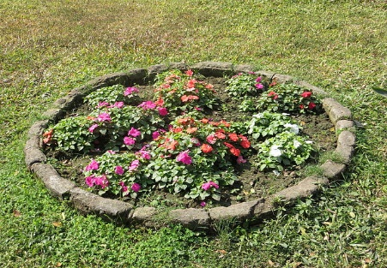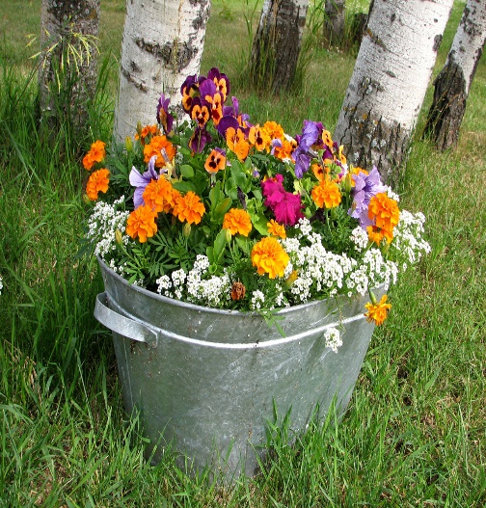
This Photo by Unknown Author is licensed under CC BY-SA

